Report by: 1409046  
Role: Level Design & Artist liaison

Game Version: Latest – with Menus  
Date Reported: 08/05/2016

QA Status: Passed

Severity: Minor

Priority: Moderate

Test Introduction:

The purpose of this test was to check that the ‘Return to Main Menu’ button was working correctly in level 2. To test this, I crashed the ship into the first rock on the map in level 2.

Expected outcome:

Main menu would be loaded.

Actual outcome:

When I clicked the main menu button level 2 would reload, this happened on the win canvas as well. But this bug would not occur on level 1.

Screenshot of the bug:

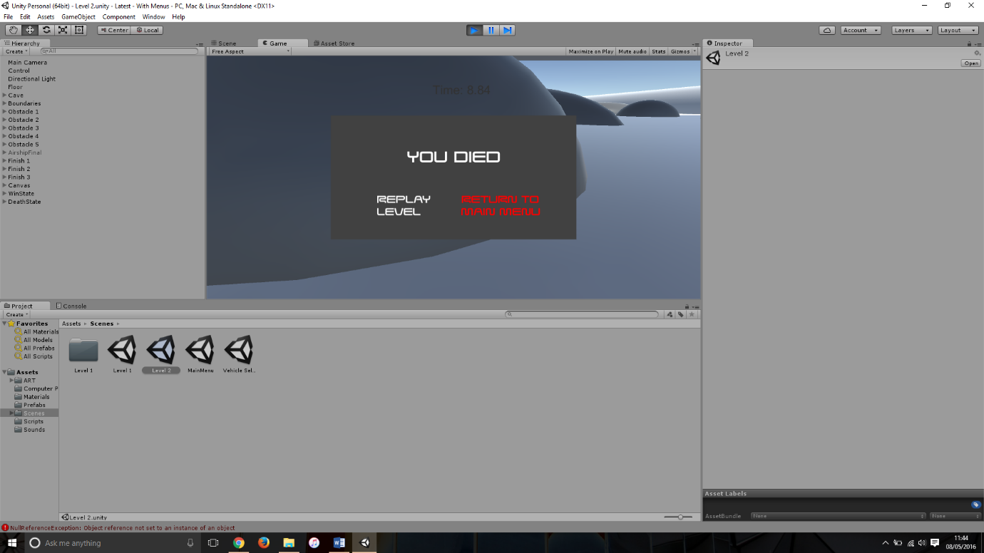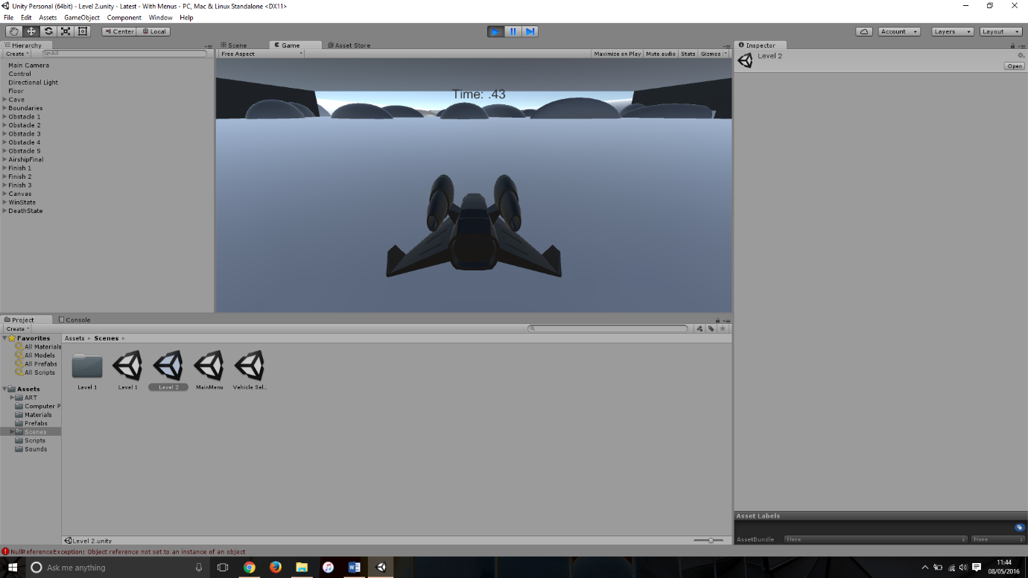

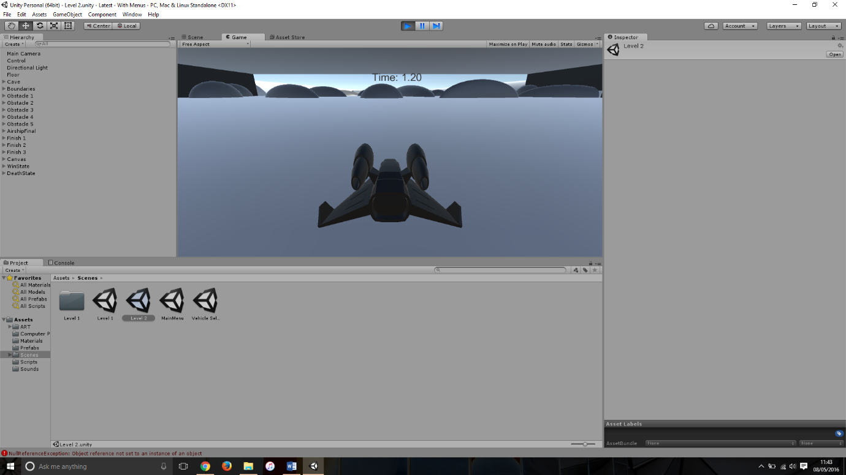

Image showing the sequence of events when the ‘Main Menu’ button is selected.

Potential cause:

A potential cause for this bug could be that the script is calling a level by name or number from the first level, meaning it would be reloading the 2nd level instead of the main menu.

Another cause for this bug could be that because scene 2 is a direct copy of scene 1 the ‘OnClick’ event could just be pointing to level 2.

Suggested Fix:

To fix this bug I had to change all of the references in the ‘menu script’ from the numbers in the build to the actual names they are called. This seemed to fix level 2 and continue to work on level 1.